PERSONAL INFORMATION Zenonas Turskis
zenonas.turskis@vgtu.lt
WORK EXPERIENCE
- Chief Researcher at Vilnius Gediminas Technical University, Faculty of Civil Engineering, Smart Building Technologies Research Institute of Smart Building Technologies, Research Laboratory of Construction Technology and Management, Vilnius (Lithuania)
- Professor at Faculty of Civil Engineering, Department of Construction Technology and Management, Vilnius (Lithuania)
- Manager at different Joint Stock Companies (more than 15 yeras)
- Computer programmer - Manager at different companies (more than 5 years)
- Senior engineer, master, chief dispatcher at construction copmpanies (more than 5 years)
EDUCATION AND TRAINING
- 1979 Civil engineer at Vilniaus CIVIL Engineering Institute (now Vilnius Gediminas Technical University), Vilnius (Lithuania)
- 1990 Applied mathematics at Kaunas Polytechnic institute (now Kaunas Technological University), Kaunas (Lithuania)
- 1993 PhD degree, Technical sciences at Vilniaus Technical University (now Vilnius Gediminas Technical University), Vilnius (Lithuania)
- 2009 Habilitation procedure, Technological Sciences, Civil Engineering (02T) at Vilnius Gediminas Technical University

ADDITIONAL INFORMATION
„International Academy of Information Technology and Quantitative Management“ (IAITQM); Academy founder, was elected a member of the awards committee ( 2012m., Omaha, Nebraska State, USA.
Member of editorial boards of International scientific journals::
- Member of the editorial board the „Journal of Civil Engineering and Management“(Thomson Reuters Web of Science), a scientific journal published by VGTU and LMA, 1995–. (ISSN 1392-1525). http://www.tandfonline.com/action/journalInformati...
- Member of the editorial board (deputy editor) of the scientific journal „Technological and Economic Development of Economy“ (Thomson Reuters Web of Science), 1994–. (ISSN 1392-8619). http://www.tandfonline.com/action/journalInformati...
- Member of the editorial board “International Journal of Information Technology & Decision Making“ (Thomson Reuters Web of Science), Singapore (ISSN 0219-6220) (2013 IF 1,890). http://www.worldscientific.com/page/ijitdm/editori...
- Member of the editorial board “Journal of Construction Engineering” (ISSN 2356-7295; CNKI Scholar; Directory of Open Access Journals (DOAJ); Google Scholar; INSPEC; J-Gate Portal); http://www.hindawi.com/journals/jcen/editors/
- The Scientific world journal / [Member of the editorial board6140 (TR WoS DB; IF 1.730)
- Member of the editorial board “Engineering Structures and Technologies”; http://www.tandfonline.com/action/journalInformati...
- Member of the editorial board “Actual Problems of Economics6788, science.net/EDITORIAL.html
Since 2012, member of FuturICT FET FLAGSHIP;
Since 2009 member of EURO working group „OR in Sustainable Development and Civil Engineering, EWG-ORSDCE“ http://www.orsdce.vgtu.lt/
Scientific interests: Civil Engineering, Construction Management, Decision Aiding, Technology, Multiple Criteria Decision Making

Information about author
https://scholar.google.lt/citations?user=mPeoXjkAAAAJ&hl=lt&oi=ao
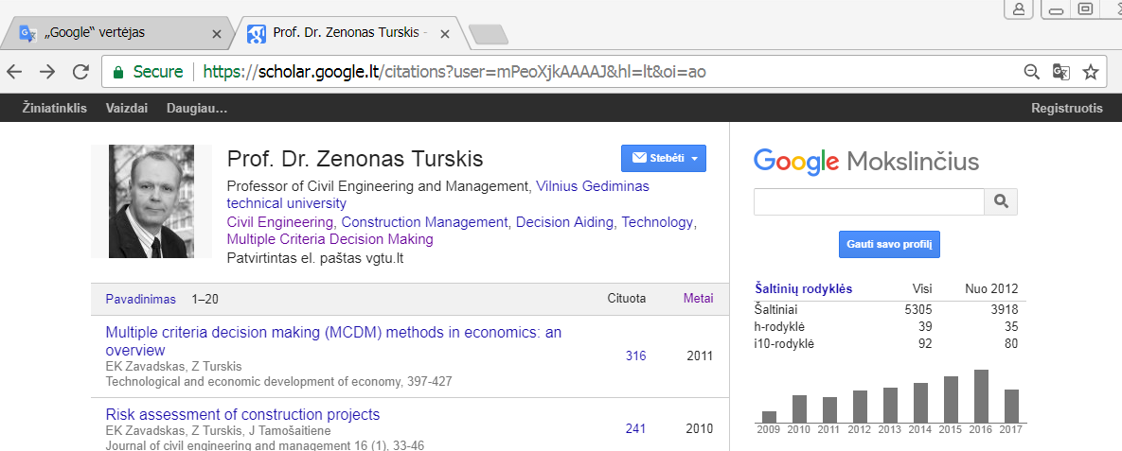
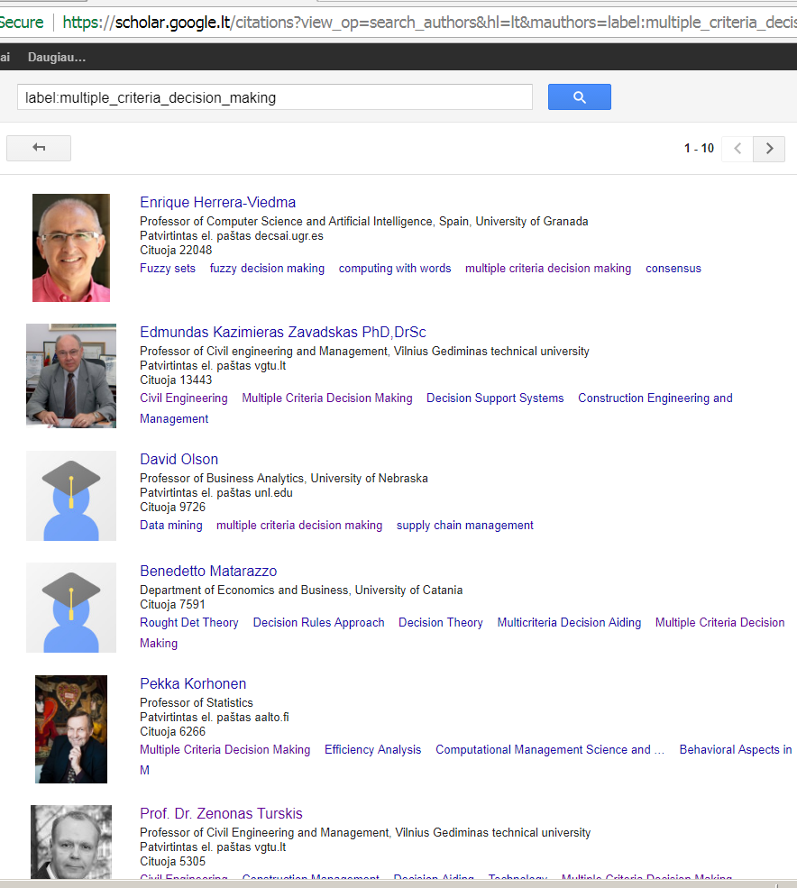

Information about Turskis on Web of Science Database
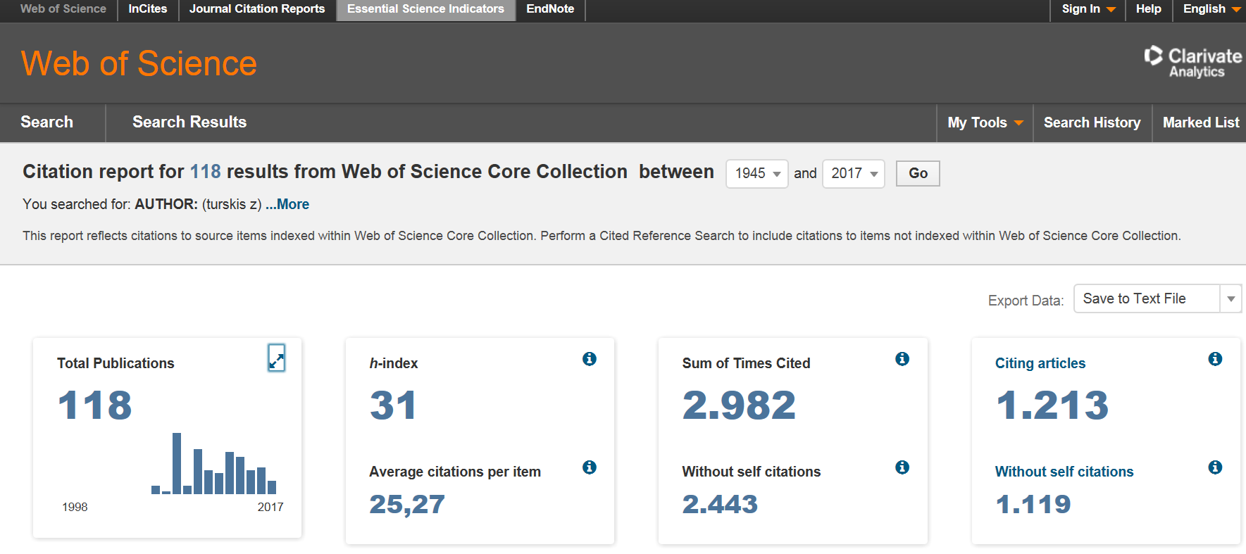
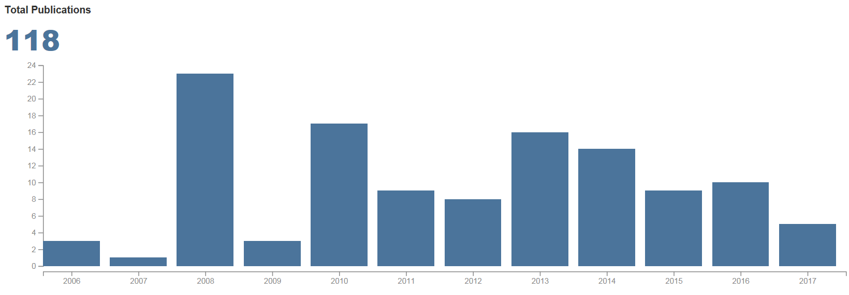
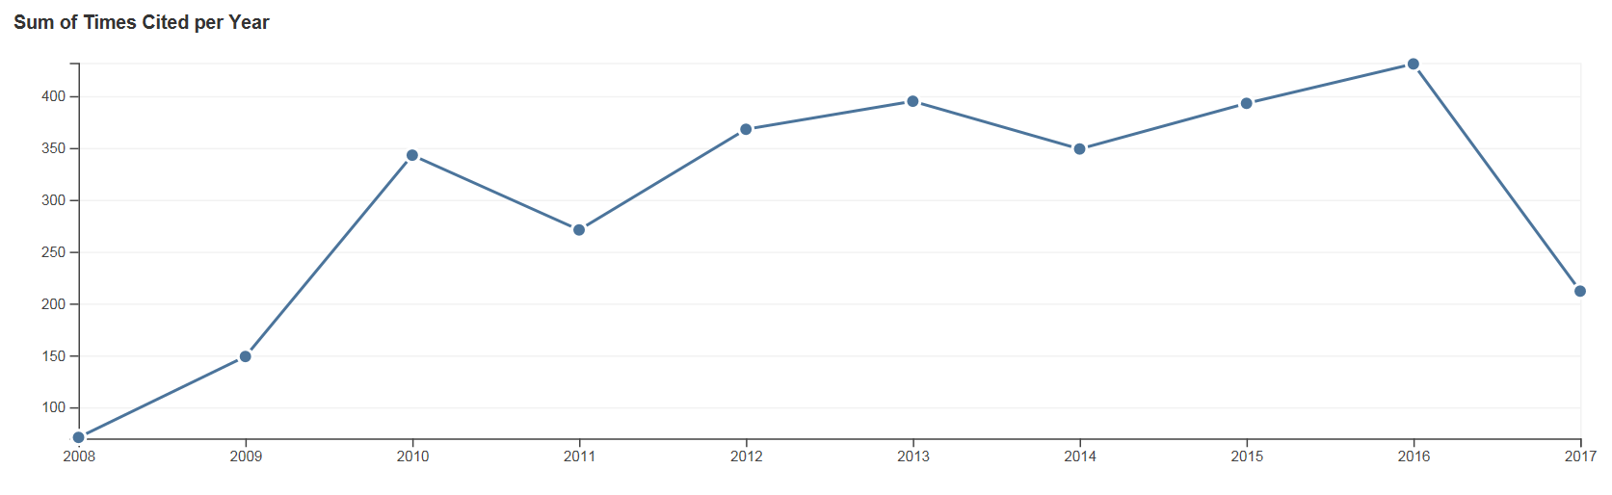

ResearchGate
https://www.researchgate.net/profile/Zenonas_Turskis
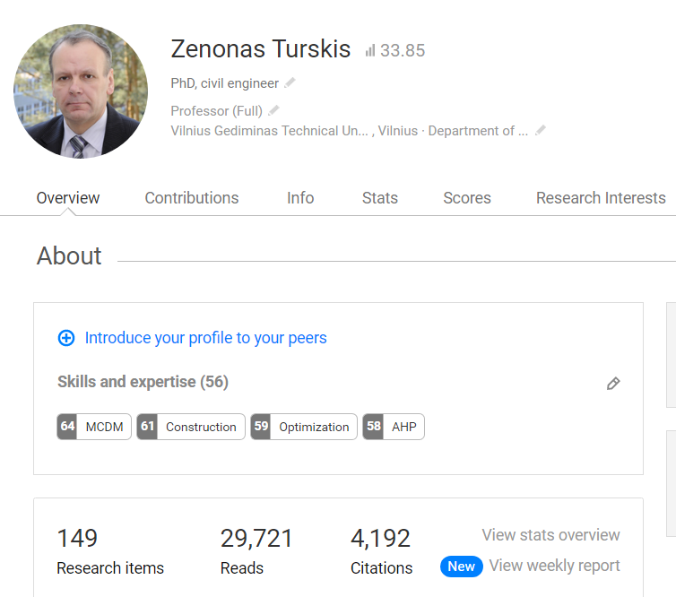
Unfortunately, at present time in VGTU is performing reorganisation of Departments. So, official web-page of Department is under reconstruction. There is temporary official web site, which was valid from 2015 year (now it could be found only in lithuanian, in english there is only one person, which is growing a litle baby)d but form September the names of departments will be changed):
http://www.vgtu.lt/statybos-fakultetas/padaliniai/statybos-technologijos-ir-vadybos-katedra/apie-katedra/51540

